Telecom - Mobile Wallet
# Source: AI Source: Provided by: [Data Path: Persons Table -> ID Column: 1, Name_En Column: Motasem Essam] -> From: [ChatGPT] on [1/21/2026]
A Telecom or Mobile Wallet is a digital wallet operated by a mobile network operator (MNO) that allows users to store money and perform financial transactions using their mobile phone number as the wallet identifier.
These wallets are especially popular in regions with limited banking access but high mobile phone penetration.

✅ Key Features of Telecom/Mobile Wallets:
# Source: AI Source: Provided by: [Data Path: Persons Table -> ID Column: 1, Name_En Column: Motasem Essam] -> From: [ChatGPT] on [1/21/2026]
- SIM or Mobile Number-Based Access
  - Wallet is linked to the user's mobile number, not necessarily a bank account.
  - Works even on basic (non-smart) phones via USSD or SMS.
- Cash-In/Cash-Out Services
  - Users can deposit (cash-in) and withdraw (cash-out) money through agent networks, such as kiosks or mobile money agents.
- No Bank Account Needed
  - Users don’t need a traditional bank account to use the wallet.
  - Great for the unbanked or underbanked population.
- Peer-to-Peer Transfers
  - Send money easily to other mobile numbers, including cross-network or cross-border transfers.
- Integrated with Telco Services
  - Used for airtime top-ups, data purchases, and bill payments directly from the wallet.

🔄 Examples of Telecom/Mobile Wallets:
# Source: AI Source: Provided by: [Data Path: Persons Table -> ID Column: 1, Name_En Column: Motasem Essam] -> From: [ChatGPT] on [1/21/2026]
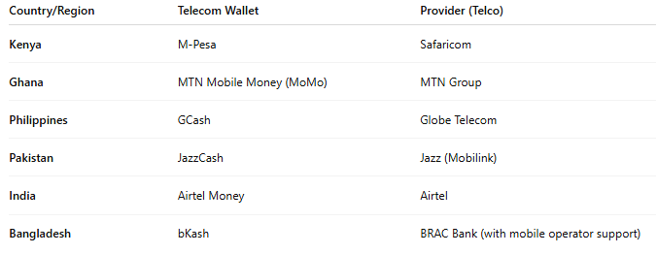

Country/Region | Telecom Wallet | Provider (Telco)
Kenya | M-Pesa | Safaricom
Ghana | MTN Mobile Money (MoMo) | MTN Group
Philippines | GCash | Globe Telecom
Pakistan | JazzCash | Jazz (Mobilink)
India | Airtel Money | Airtel
Bangladesh | bKash | BRAC Bank (with mobile operator support)

🛠️ How It Works:
# Source: AI Source: Provided by: [Data Path: Persons Table -> ID Column: 1, Name_En Column: Motasem Essam] -> From: [ChatGPT] on [1/21/2026]
- Registration with a mobile operator (via SIM and national ID)
- Deposit money via mobile money agent or ATM
- Use wallet for:
  - P2P transfers
  - Merchant payments (QR/NFC)
  - Bill/utility payments
  - Airtime purchases
- Withdraw cash via agents or transfer to a bank account

✅ Advantages:
# Source: AI Source: Provided by: [Data Path: Persons Table -> ID Column: 1, Name_En Column: Motasem Essam] -> From: [ChatGPT] on [1/21/2026]
- High accessibility (no bank account or smartphone needed)
- Widespread agent networks in rural and urban areas
- Financial inclusion for unbanked populations
- Low transaction fees

⚠️ Challenges:
# Source: AI Source: Provided by: [Data Path: Persons Table -> ID Column: 1, Name_En Column: Motasem Essam] -> From: [ChatGPT] on [1/21/2026]
- Agent dependency for cash transactions
- Limited KYC in some regions
- Fraud and SIM swap risks
- Regulatory constraints in cross-border use

🆚 Comparison with Other Wallets:
# Source: AI Source: Provided by: [Data Path: Persons Table -> ID Column: 1, Name_En Column: Motasem Essam] -> From: [ChatGPT] on [1/21/2026]
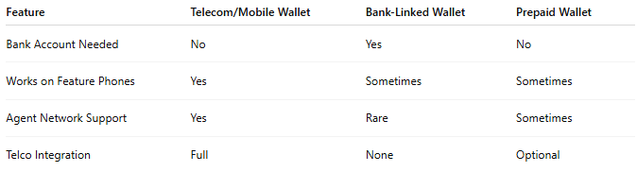

Feature | Telecom/Mobile Wallet | Bank-Linked Wallet | Prepaid Wallet
Bank Account Needed | No | Yes | No
Works on Feature Phones | Yes | Sometimes | Sometimes
Agent Network Support | Yes | Rare | Sometimes
Telco Integration | Full | None | Optional

